Week 3 Day 2 Assignment

With vibe coding implement the below

1)Connect to jira via api
2)Fetch the user storie from jira to generate testcases

Implementation done - updated to fetch stories, tasks and bugs from JIRA

Prompt used
Analzye my existing code base and Implement Jira integration
GO STEP BY STEP up on my approval proceed with next step
--[Mandatory] Backend first then proceed with Frontend

Instruction
[MANDATORY] Implement Jira connectivity email,api key should be configurable
[CRITICAL] Fetch the Projects from Jira (Projects should be autopopulated as dropdown)
[CRITICAL] Fetch User stories for the project (user stories should be autpopulated
as dropdown)
-- When there is a story selected in Select User Story drop down, the api should fetch the details listed and create test cases when generate button is click.
-- When a story selected in Select User Story drop down, the user is not asked to enter details in the Manual section.
-- When a story is selected, the fields get populated and are ready to generate.
-- Look for Acceptance criteria in the acceptanceCriteria. If no value is present check in Description field After the key word "Acceptance Criteria" and use the content as Acceptance criteria in the UI

REFER MY POSTMAN COLLECTION

Updated UI

Added option -> Select Jira Project, which lists the available stories, tasks and bus in Select User Story as drop down

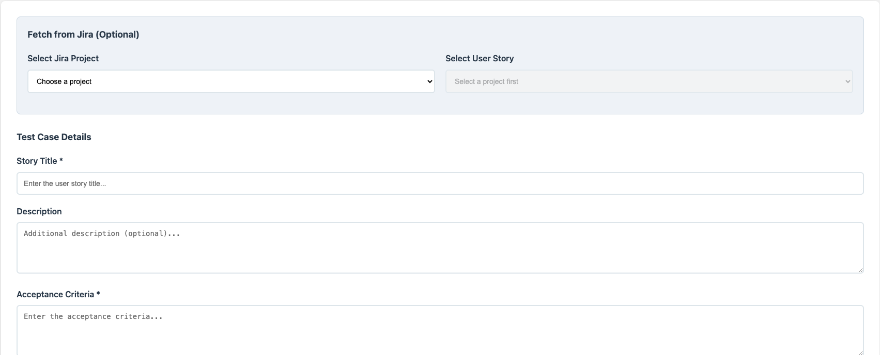

When Project is selected in Select Jira Project All Stories, Bugs and Tasks are autopopulated in Select User Story

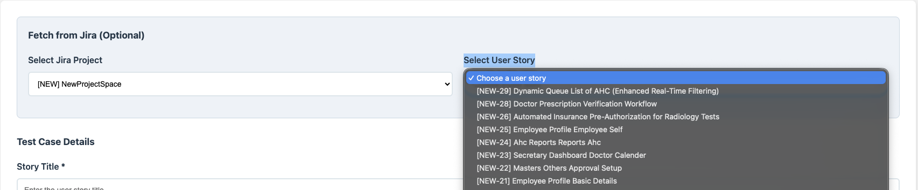

After the user story is selected in Select User Story dropdown, the story details are loaded form the story in the manual form

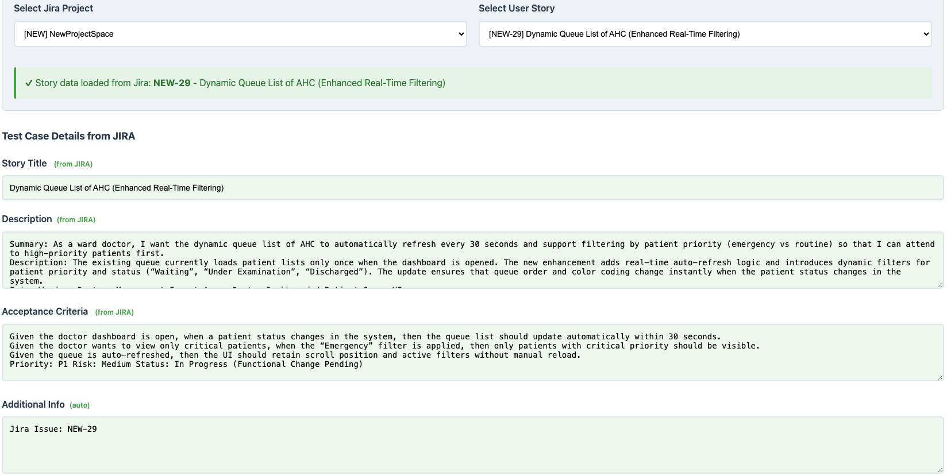

Click on “Generate” Button will generate test cases

